**Case Study 1: High Availability Microservices Deployment**

**Scenario:**

**A growing e-commerce startup faces frequent website crashes during peak traffic. They need a scalable solution.**

**Step 1:** Building and Containerizing the Flask Application.

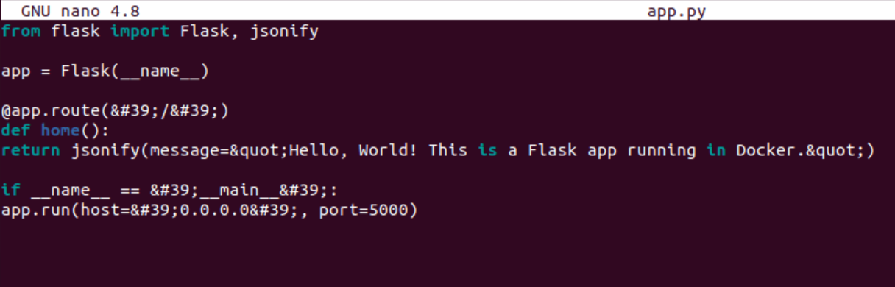

**Step 2:** Creating the Dockerfile.

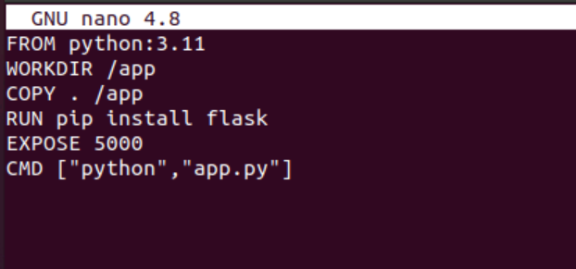

**Step 3:** Build and push the image.

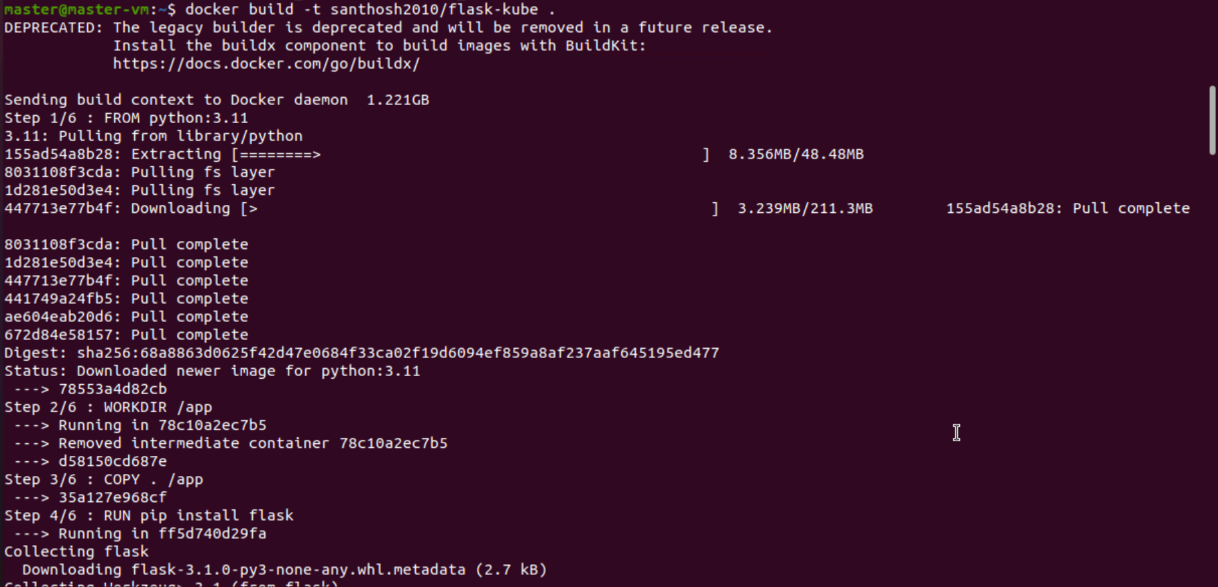

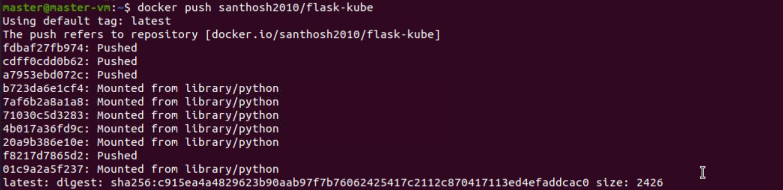

**Step 4:**Deploying Flask app in Kubernetes

**_** Creating deployment-service.yaml

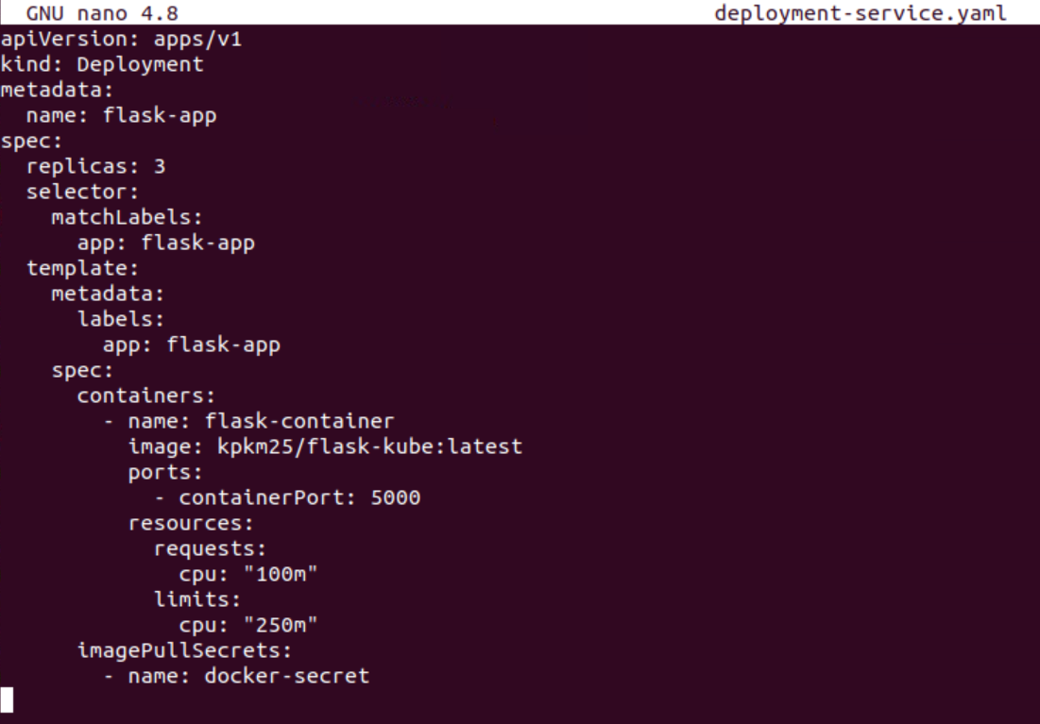

**Step 5:** Applying for the Deployment.

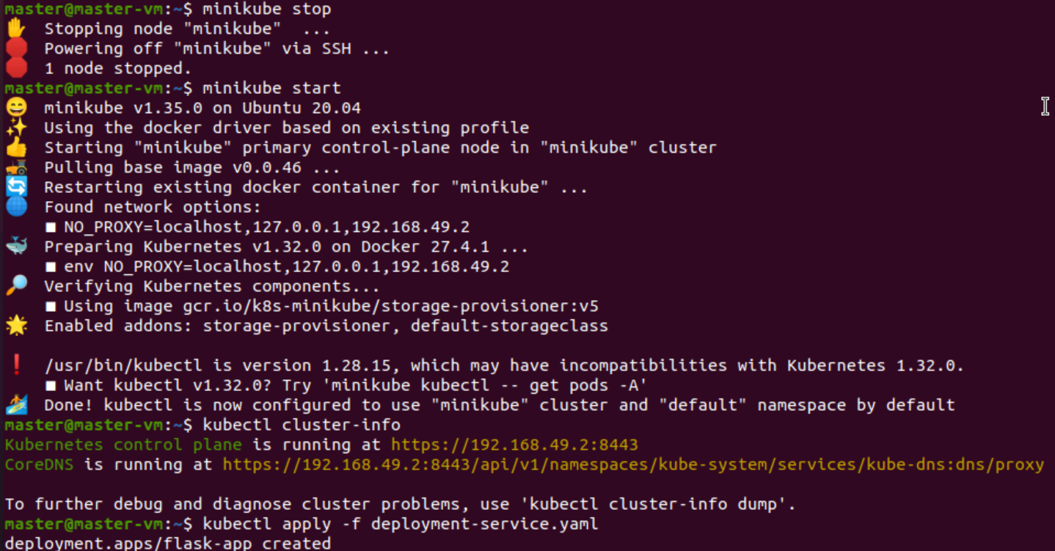

**Step 6:** Create a Docker Secret registry.

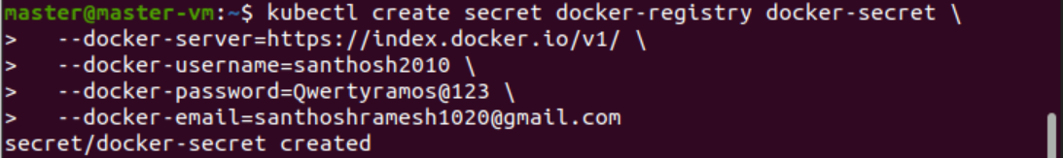

**Step 7:** Creating a Patch Default Service Account.



**Step 8:** Installing and Troubleshooting Metrics Server

